ME 200 – Thermodynamics, L. Liebenberg

**Name:** Joseph Specht **Net-ID:** jspecht3

**Quiz 5** (Total: 40 points) **Due back on Wed. Feb. 22 at 10 p.m., in Canvas**

* *Assignments will only be graded if the honor code statement is completed and signed.*
* *Save your entire assignment as one* ***PDF document*** *and upload it in the appropriate assignment folder on Canvas.*

**Honor Code Statement**

***ME 200, Quiz 5***

Being a student of high standards, I pledge to embody   
the principles of *academic integrity*.

This quiz is my own work. I did not seek (or get) outside help or collaboration with any of the questions and their solutions. I did not post any of the questions on an electronic platform (like Chegg) nor did I solicit answers or solutions from any electronic platform (like Chegg). I also did not offer my solutions or answers to any other student.

I understand that this quiz is “open book” and “open notes” which means that I was permitted to use my prescribed textbook and lecture notes when addressing any of the questions. I have properly cited any other resources, with full cognizance of the regulations pertaining to plagiarism, copyright infringement, academic cheating, etc., as stipulated in the Student Code.

I acknowledge that academic violations will be dealt with according to the UIUC Student Code,   
Article 1, Part 4.

Student’s signature:________________________________________________________________



Student’s Name: Joseph Specht

Net-ID: jspecht3

Date: 2/21/23

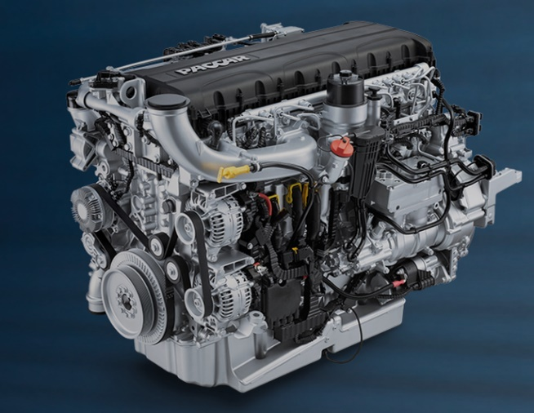A citybus engine has the following characteristics:

Engine displacement: 12.9 liters

6 cylinders, in-line placement;

Fuel: Diesel

Compression ratio: 18.5:1

Cut-off ratio: 2.5

The engine’s inlet conditions are 20ºC and 1 bar

Maximum engine pressure: 5 MPa

Using an ideal air-standard Diesel cycle, calculate the following and remember to show all your calculations:

* 1. the temperature and pressure at state points 1, 2, 3, and 4. (15)

12.9-liter DAF diesel engine, courtesy of *DAF/Paccar Trucks* <https://www.dafcomponents.com/en/products/paccar-daf-engines>

* 1. the heat and work transferred in each of the four processes. (20)
  2. The cycle’s thermal efficiency.

**η = 55.9%**(5)

Summarize your calculated values of temperature, pressure, heat, work, and change in internal energy. (-5 points if tables are not completed.)

5000 (given)

100 (given)

$$799.42$$

$$338.95$$

5000 (given)

$$1998.55$$

$$1003.58$$

293 (given)

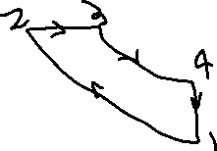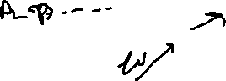

|  |  |  |  |
| --- | --- | --- | --- |
| **Process** | ***q* (kJ/kg)** | ***w* (kJ/kg)** | **Δ*u* (kJ/kg)** |
| ­1 – 2 | 0 | $$-422.35$$ | 422.35 |
| 2 – 3 | $$1344.22$$ | $$344.15$$ | 1000.07 |
| 3 – 4 | 0 | $$829.80$$ | - $829.80$ |
| 4 – 1 | -592.62 | 0 | -592.62 |
| Cycle: | *q*net = 751.6 | *w*net = 751.6 | 0 |

Relevant Information For all Processes:

This is taken from Table A-20. The assumed temperature is 900*K

* c_v = .834
* c_p = 1.121
* k = 1.344

1-2: Adiabatic Compression

* Compression Ratio = 18.5:1 = V_1 / V_2
* Initial Temp = 20*C = 293*K
* Initial Pressure = P_1 = 1 bar = 100 kPa
* Max Pressure = P_2 = 5 MPa = 5000 kPa
* V_1 = 12.9 Litres

Since this is an adiabatic process,

$$\frac{T_{2}}{T_{1}}={\left(\frac{V_{1}}{V_{2}}\right)}^{k-1}=>T_{2}=T_{1}*{\left(18.5\right)}^{.344}=293K*2.665=799.42K$$

Since this is a adiabatic process in a closed cycle, q=0 and…

$$w=-Δu=-c_{v}*ΔT=-.834*\left(799.42-293\right)=-422.35\frac{kJ}{kg}$$

This also means that Δu = -w = -422.35 kJ/kg

2-3: Constant Pressure Heat Injection

* Max Pressure = P_2 = P_3 = 50 bar = 5000 kPa
* Cut-off Ratio = V_2 / V_3 = 2.5

Since this is a constant pressure process…

$$\frac{v_{2}}{T_{2}}=\frac{v_{3}}{T_{3}}=>T_{3}=\frac{v_{3}}{v_{2}}*T_{2}=2.5*T_{2}=2.5*799.42K=1998.55K$$

We also know that in a closed system with constant pressure, so

$$q=Δh=c_{p}*ΔT=1.121\frac{kJ}{kg*K}*\left(1998.55K-799.42K\right)=1344.22\frac{kJ}{kg}$$

From the first law, we know that w = q – Δu, so

$$w=q – c_{p}*ΔT=1344.22\frac{kJ}{kg}-.834\frac{kJ}{kg*K}\left(1998.55K-799.42K\right)=344.15\frac{kJ}{kg}$$

$$u=q-w=1000.07\frac{kJ}{kg}$$

3-4: Adiabatic Expansion

* P_4 / P_3 = (P_4 / P_2) / (P_3 / P_2) = Compression Ratio / Cut-Off Ratio = 7.4
* P_3 / P_4 = 1 / 7.4 = .135
* P_3 = Max Pressure = 50 bar
* V_4 = V_1 = 12.9 Litres

We know this is an adiabatic process, so we can use the equations,

$$p_{4}=p_{3}*{\left(.135\right)}^{k}=5000kPa*{\left(.135\right)}^{1.344}=338.95kPa$$

$$T_{4}=T_{3}*{\left(.135\right)}^{k-1}=1998.55K*{\left(.135\right)}^{.344}=1003.58K$$

Since this is an adiabatic process,

$$Δu=-w=c_{v}*ΔT=.834\frac{kJ}{kg*K}*\left(1003.58K-1998.55K\right)=-829.80\frac{kJ}{kg}$$

$$∴w=829.80\frac{kJ}{kg}$$

We also know that work is -Δu, ∴ Δu = -829.80 kJ/kg

4-1: Constant Volume Heat Rejection

* V_1 = V_4 = 12.9 Liters

Since the volume is the same, we know work is 0.

$$Δu=q=c_{v}ΔT=.834\frac{kJ}{kg*K}\left(293K-1003.58K\right)=-592.62\frac{kJ}{kg}$$

To find η, we apply the following formula,

$$η=\frac{w_{net}}{q_{in}}*100=\frac{751.6}{1344.22}*100=55.9\%$$